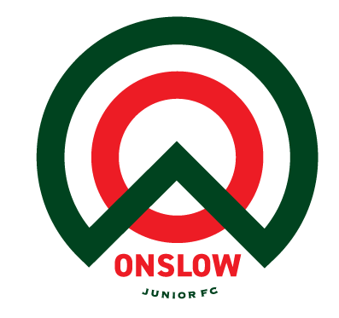

Introducing the Onslow JFC Youth Ready Programme (YRP)

What is it?
The Youth Ready Programme which is being offered to U12 Mixed, U13 Mixed and U13 Girls Only for the 2026 season, is a targeted programme designed to prepare players for the competing demands of the Talent Development Programme (TDP). OJFC coaches will focus on developing the technical, tactical, physical, and mental aspects of each player’s game, ensuring they are well prepared for the transition into TDP, which begins at U14 for mixed players and U15 for girls-only.
Training will be delivered by the Club Technical Director and the Girls Lead, ensuring the highest possible quality of coaching and training environment.
The programme aims to provide players with the most appropriate training and guidance to help them achieve their football ambitions—whether that is progressing into TDP, competing in the National League, or pursuing other footballing opportunities.

When is it?
The selection process will begin in the week commencing 16 February 2026. It will involve two training sessions per week over a two-week period, with internal games played on weekends. During this time, coaches will identify squads of 12–14 players who will train and compete together for the remainder of the programme.
Selection will be based not only on technical ability, but also on players who are coachable, eager to learn, competitive, and committed to maintaining high standards at both training and games throughout the entire season. Most importantly, selected players must consistently demonstrate the RISE values.
Following the selection period, players chosen for the programme will have a one-week break before full training begins in the week in commencing 9 March.
The 2026 programme includes two training sessions per week delivered by the Technical Director and Girls Lead, alongside weekly games in the regional grades. Teams will also represent the club at tournaments the club gains entry into, such as Kapiti Pre-Season, Wests Graded, Christchurch International Cup, and Taupō McCartney. Please note that an entry fee applies for each team attending tournaments.
Training will run from the first week of March through to the end of the winter season. During Term 1, there will also be internal games and/or organised friendly matches against other clubs.

Methodology
While development is the primary focus, we aim to provide the most appropriate competitive game-day experience for players. All training sessions are designed to create a positive learning environment—one where players are not afraid of making mistakes, but instead feel encouraged to be proactive and try new skills.
Our sessions are player-centred: questions are welcome, opinions are valued, and learning is shared. Training is built around four core areas of development: technical, tactical, physical, and mental. These areas are prioritised based on a player’s development stage, with technical skills emphasised ahead of tactical understanding in the earlier years.
Sessions simulate real game situations and include clear individual and team tasks, as well as appropriate opposition to challenge players.
Our coaching philosophy emphasises giving the player on the ball the responsibility to make decisions based on what they see, rather than waiting for what they hear. This approach builds vision and awareness, encourages creative decision-making, and strengthens cognitive development. Coaches will focus closely on technical details and will not progress players to new topics until a high level of competency is achieved.

